Attention: Direct Sales (Reps+)
Impacted Markets: All
Effective: November 3rd

Mobile Onboarding Process Update

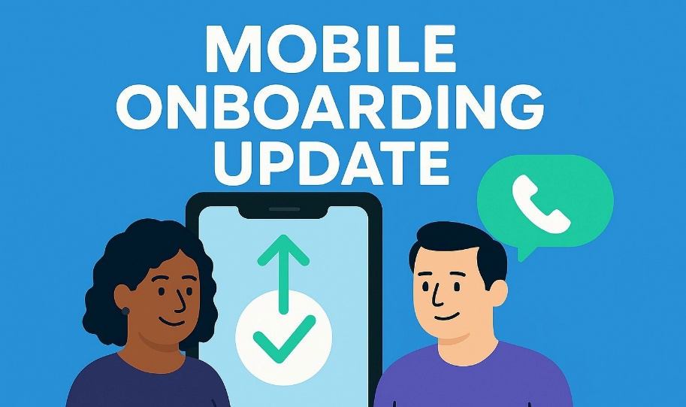

Big news! Our Mobile Onboarding process just got better — making it easier than ever to complete mobile sales and deliver a faster, smoother experience for our customers. See details below:

+ What:
- Direct Sales now has the option to hand off a Mobile sale to our Mobile Care Rescue Team for completion when experiencing issues during the port-in process.
+ How
- Easy! Have the customer contact the Mobile Care Rescue Team by dialing 866-200-7066 using their existing cell phone or landline. After you select a language option, select option 1. This will directly transfer the call to our Mobile Rescue team.
Below is the pop-up message you will see:

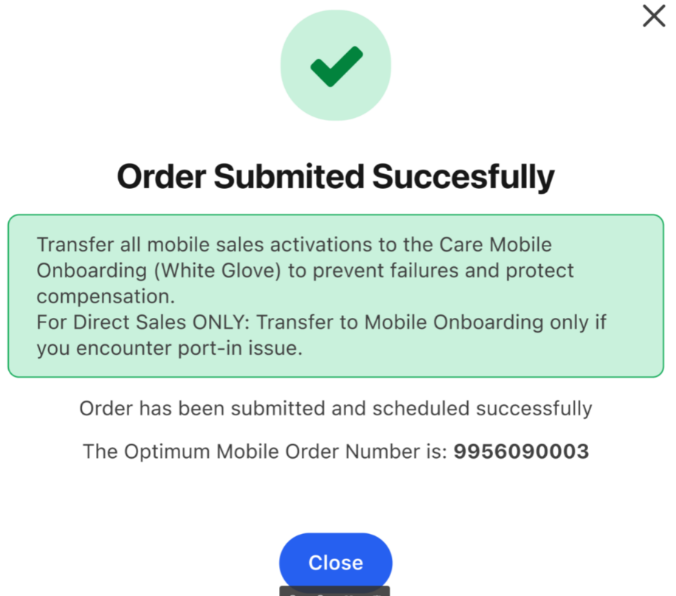

+ Why does this matter?
- Having a team readily available to complete the mobile process will allow us to knock more doors while our customers receive an even better customer experience!
+ When:
- Launch Day is November 3rd.

Mobile Rescue Team Hours of Operation:
M-F: 8am–10pm
Sat, Sun: 8am–8pm

FAQs:
Question: If my customer opts in for BYOD & eSIM, how quickly can they complete the activation?
Answer: Activation can be completed within minutes.

Question: Will our Mobile Care Rescue Team assist with the port-in process?
Answer: Yes — the team is readily available to support the port-in process.

Question: Does the Mobile Care Rescue Team have access to tools or workarounds that I don’t currently have access to?
Answer: No.

Escalations:
If you encounter an issue that requires escalation, please send it to your leader. They will route it to the Mobile Care Rescue Team contact for resolution.

Thank you for your attention to this update and for continuing to drive great results for our customers and our team.

